Opening Declaration: I promise to do this assignment authentically   
Student Signature: ________________________ Date:_________

Familial Adenomatous Polyposis

***Introduction and Background***

***Basic Genetic Background***

Familial adenomatous polyposis (FAP) is a genetic disorder caused by a mutation in the APC (Adenomatous Polyposis Coli) gene. APC is a tumor suppressor gene. The mutation on the APC gene is autosomal dominant. There is a 50% chance of FAP being passed onto a child if one parent has one allele of it and the other does not, and a 100% chance of FAP being passed onto a child if one parent has both alleles. Not all cases of FAP are inherited. The American Society of Clinical Oncology states that "About 30% of people with FAP do not have any family history of the condition; they have a de novo(new) mutation in the APC gene," [1]. This gene is located at 5q21 to 5q22, which includes the base pairs 112,707,505 to 112,846,239 [2]. In layman's terms, the APC gene is located on the fifth autosome's longest arm between the 21st and 22nd band. There are numerous subsets of classical FAP: such as attenuated FAP (AFAP), Gardner syndrome and Turcot syndrome. FAP is usually caused by nonsense mutations that creates a premature stop codon or frameshift mutations.

***Symptoms***  
 Regular APC protein allows for proper movement and growth of epithelial cells in the colon. This results in the proper formation of folds and bumps in the colon that increase surface area for absorption as part of the digestive system. However, if a person has FAP, some of this folding goes awry. The APC protein's effect on cell adhesion, replication, and mobility results in polyp growth instead. This may lead to bloody stool being excreted. These polyps will continue to grow in both size and number. If left untreated, this will soon become colonic cancer. There are numerous other cancers that do, but rarely, occur in families with FAP: Hepatoblastoma, a type of liver cancer seen in young children; desmoid tumors/desmoid fibromatosis, a locally aggressive tumor that does not metastasize; papillary thyroid cancerl pancreatic, adrenal, and bile duct tumors; and a type of brain tumor called medulloblastoma, commonly found in children [1]. Non cancer related symptoms include bone growths in the jaw, gaining or losing teeth, changes in skin and growths in the adrenal region [1]. Note that while these effects are rare amongst those that suffer from FAP, the main issue with FAP is colonic cancer. FAP is a late onset disease that begins to show these symptoms during the early teen. These symptoms do not become big problems until the late teenage years.

***Site of Lesion***  
 As stated before FAP is a mutation of the APC gene that results generally from frameshift mutations or nonsense mutations. The APC gene is transcribed to make Beta-catenin. This protein has multiple functions, but the presence of mutations causes this protein to be shorter. Unfortunately, the multiple roles of beta-catenin means that if it cannot perform up to standard, a cure for FAP that fixes all the problems becomes difficult. Some functions of beta-catenin are in the cell adhesion/cytoskeleton and the WNT pathway, which are detailed below.  
 ***Effects on Cell Adhesion and Cytoskeleton***

The wild type or normal function here is for epithelial cells to stick to each other tightly. However, with FAP, cells stick to each other loosely. As epithelial cells move and grow, this loose sticking leads to colonic tissue growing in the wrong direction. This forms polyps that eventually develop into colonic cancer.   
 Intercellular adhesion in epithelial cells is governed by calcium dependent glycoproteins called cadherins. These cadherins are connected to another cells' cadherins via bonds between calcium atoms. These connections only connect cell membranes however. A cadherin must be connected to its cells' cytoskeleton to maintain a firm connection. A cell accomplishes this first by using either beta-catenin or E-cadherin. Either of these two inside the cell will attach to a cadherin glycoprotein. Then either of these two will attach to alpha catenin. Finally, alpha catenin attaches to the cell cytoskeleton[5]. The APC interacts with beta-catenin, which in the presence of FAP, may cause beta-catenin to have a weaker bond in the chain described above.  
 There is evidence that FAP affects APC related colon cancer in mice. In a study where a functional APC gene was reintroduced into mice colon cancer cells, specifically SW480APC, the changes noted were "a reduced proliferation rate, a reduced ability to form colonies in soft agar and do not grow tumors in a xenograft mouse tumor model," [4]. A reduced proliferation rate and tighter adhesion proves that the APC gene governs cell replication and cell adhesion. The absence of tumors also means that the APC gene is a tumor suppressor.   
 APC also has a role in microtubule development. Microtubules are a crucial part of the cytoskeleton. Normal/wild type APC function in epithelial cells are that "microtubules decorated with APC at their plus ends spend increased time in growth and decreased time shortening," [6]. However, in mutant APC proteins, they interact with microtubules indiscriminately. They will execute their lengthening function on microtubules that do not need to be longer. The end result with this mutated APC are microtubules that should be short to be longer then they need to.  
 ***Effects on the WNT Pathway***

The APC protein plays a vital role in the WNT pathway. WNT is a combination of two abbreviations, "int" for integrated, and "WG", meaning wingless. WNT's overall meaning is wingless-related integration site. When the pathway is unactivated, "cytoplasmic beta-catenin forms a complex with Axin, APC, GSk3, and CK1, and is phosphorylated by CK1... and subsequently by GSK3," [3]. This effectively targets beta-catenin for destruction by a proteosome. When the pathway is activated, the destruction complex is not formed and beta catenin is allowed to accumulate. As beta catenin accumulates, some of it is allowed to localize in the cell's nucleus. In the nucleus, TCF is bound to DNA. When beta-catenin bonds with TCF, tumor suppressing genes are transcribed from the DNA.  
 What was described was the wild-type function of APC in the WNT pathway. However, with FAP, the APC gene is shortened. APC is only used when the WNT pathway is inactivated. When the pathway is off, APC is supposed to form a destruction complex that targets beta-catenin for destruction. However, due to APC's shortness with the presence of FAP, the destruction complex either never forms or forms improperly. Either way, beta-catenin is not targeted for destruction with the mutation in the APC gene. If beta-catenin is not destroyed by a proteosome, it will be allowed to accumulate. Beta-catenin is only supposed to be allowed to accumulate when the pathway is turned on. With FAP, it is as if the WNT signaling pathway is always on. Beta-catenin is allowed to accumulate in the cytoplasm, where it then localizes in the nucleus. Since the WNT signaling pathway is effectively always on, epithelial cells will always be transcribing the section of DNA governed by the TCF protein.  
 ***Detection, Treatment, and Management***

***Detection***

Detection is vital to living with FAP. The colonic cancer that is characteristic to FAP appears during or shortly after someone's late teens. If at least one of the parents has FAP, then the child must be checked for the development of polyps in the early teenage years. A "flexible sigmoidoscopy should be performed every 1-2 years starting at age 10-12 year in a patient with FAP to document the onset of polyposis," [7]. If by chance, a child is born with FAP in a family with no history of it, the early symptoms that may occur are constipation and blood in the stool.  
 ***Treatment***

Once the presence of FAP is confirmed, the recommended surgeries are "Illeal pouch-anal anastomosis (J-pouch) surgery, total colectomy, and continent ileostomy," [8]. A total colectomy carries the risk of bleeding inside the belly, damage or blockages to the nearby organs, and leakage of stool. This solution solves colonic cancer by just removing the colon. Illeal pouch-anastomosis surgery or continent ileostomy are surgeries typically done after a total colectomy. Illeal puch-anastomosis surgery is where the small intestine is curved into the shape of a "J" so that it can store waste. The small intestine is then connected to where the colon would have been connected to the anus. This retains the ability to use the anus to pass stool, but a downside of this is problems with reproducing. An alternative to this is a continent ileostomy, where the small intestine is connected to the skin via an opening called a stoma. A bag is attached to the stoma to store waste. This comes with the downsides of the stoma having to be frequently checked for infection and having a harder time getting drunk.   
 ***Management***  
 After the previously mentioned surgeries, the patient most spend the majority of their lives watching what they eat. They cannot eat anything that may cause constipation, excess amounts of gas, and food that creates large and hard stool. The surgeries are also followed up with a lifetime of taking either sulindac or celecoxib. "Celecoxib is no longer widely used because of the association between cycloxxygenase 2 (COX-2) inhibitors... and coronary artery disease," [7]. Despite this risk, both drugs are used with the intent to reduce inflammation as well as to suppress intestinal tumors. It has been found that FAP tumors over express COX-2, which may explain the tumor suppressing effect these two drugs have. No palliative care exists for FAP due to the fact that the colonic cancer caused by FAP cannot occur without a colon.

***Treatment Proposal***

***Developing Cures***

Developing a complete cure is generally a problem due to the fact that APC protein has many roles in the cell that affect cell mobility, replication, adhesion, and more. Solving one issue is likely to only reduce the number of polyps.   
 It was previously mentioned that in the WNT pathway, the APC protein was too short to form the destruction complex that tags beta-catenin for destruction. The accumulation of beta-catenin allows for it to localize in the nucleus where it binds with TCF to over transcribe tumor suppressing DNA. This ends up causing polyp growth and cancer. One proposed mechanism for interfering in the WNT pathway is "a drug that interferes with Beta-catenin interaction with TCF, ICRT3," [9]. The chemical formula for ICRT3 is C16H17NO5S2. This drug is soluble in DMSO (Dimethyl sulfoxide), an organosulfur cmpound capable of dissolving some polar and non polar compounds. ICRT3's solubility in DMSO makes its solubility in the body questionable, so it has yet to be approved for use in humans, but it is effective in mice [10].   
 Eflornithine (or alpha-difluoromethylornithine) has also been tested. While this drug has typically been used to treat excessive facial hair growth and African sleeping sickness, it has also been found to "siginicantly reduce polyps in patients with a history of large colon polyps but who did not have FAP. There are also studies that show a reduction in polyps in patients with FAP," [11].   
 A third experimental drug that Lindsey is taking is called MGD007. "According to Dr. Herbert Hurwitz, the medical oncologist overseeing the trial at Duke Cancer Center in Durham. It’s believed to work by enabling the immune system to recognize and attack the cancer cells," [12]. This is more of a general drug that targets colon cancer in general as opposed to FAP specific problems. In fact, most drugs in development treat FAP as just another way for colon cancer to form. They treat colon cancer, not FAP. They do not directly interact with any of the APC protein's function.  
 There is also a protein called ICAT, that is an "81 amino acid protein termed ICAT (inhibitor of β-catenin and Tcf). ICAT inhibits binding of β-catenin to Tcf-4 (and) disrupts β-catenin/Tcf/DNA complexes," [17]. The issue with this is that when placed into a cell by itself, it will " localizes to both cytoplasmic and nuclear compartments," [18] and "degree to which it alters other beta-catenin functions is less well understood," [18]. Beta-catenin has other functions outside of the nucleus, such as connecting the cell's cytoskeleton to a calcium-dependant glycoprotein intercellular connector mentioned before. ICAT may stop beta-catenin from interacting with TCF in the nucleus, but may have unintended side effects outside the nucleus.  
 ***Molecular Intervention Therapy***

This therapy is aimed at actually targeting a specific facet of FAP: the lack of destruction of beta-catenin in the WNT signaling pathway. The cure will be a protein that interferes with the bonding between TCF and beta-catenin in the nucleus to prevent TCF-related genes from being transcribed. Since the symptoms of FAP could possibly show in the early teens, but can only be detected in the early teens, the intervention should start during the early teens. The target tissue is epithelial tissue in the colon. The barriers against this deployment of a portion into the nuclei of epithelial cells in the human body are the body's digestive juices, the cell membrane, and the cell nuclear membrane. The proposed cure must not be digested before the colon, so it must navigate through the stomach's digestive juices and the small intestine untouched. A protein cannot travel past the cell membrane and cell nuclear membrane without being encased in something.   
 ***Getting Past the Digestive System to the Colon***

The goal is getting this medicine to deploy in the colon, and nowhere else. This can be done using a capsule with a casing made of copolymers of methacrylic acid and methyl methacrylate filled with guar gum. Methacrylic acid and methyl methacrylate are polymers that when used in conjunction with each other, were found to be " appropriate for drug delivery to the ileocolonic region," [13]. This region is right before the colon, so to ensure delivery, the pill will be filled with guar gum. Guar gum both acts as something to suspend the protein in besides empty space as well as ensuring delivery only to the colon because study has shown that guar gum does not degrade until it reaches the colon where bacteria degrade the capsule, allowing for the slow release of the encased drug [14].   
 ***Getting Past the Cell Membrane and Nuclear Membrane***

A protein cannot naturally pass through a cell's membrane and nuclear membrane. However, using a specially designed micelles, this can be accomplished. The University of Tokyo has engineered micelles that " penetrate the cell membrane in a different way, entering the cell through a process called endocytosis... As conditions become more acidic, the molecules of the micelles... lose their ability to stick together and release the drug molecules," [15]. These micelles can further be engineered to be "nanocarriers functionalized with nuclear localizing signals (NLSs) ... (that) can efficiently enter cells and localize in their nuclei," [16].  
 By having a micelles engineered to be taken in through endocytosis, they can deliver a protein past the cell membrane. The micelle can further be engineered to generate a nuclear localizing signal, so that the micelle can be taken into the cell's nucleus. The micelle can then respond to the change in pH inside the nucleus, where it will break up, and then released the enclosed protein.  
 ***The Protein Cure***  
 The protein that will be in the cell nucleus must effectively replicate the effect of the WNT signaling pathway being inactivated. Recall that when the pathway is inactive, the APC protein that is affected by FAP is too short to form a destruction complex that tags beta-catenin for destruction. This results in beta-catenin accumulating and localizing in the nucleus where it binds with TCF. This activates the transcription of TCF related genes. The protein that is part of the proposed cure must bond to TCF such that beta-catenin cannot bond to TCF to trigger transcription. This protein is ICAT, which is ICAT is a protein that by inhibiting the binding of beta-catenin to TCF, will restore the WNT pathway when it is off. FAP results in the destruction complex of the WNT pathway's inactive state to fail, thereby allowing beta-catenin to accumulate. The beta-catenin then localizes in the nucleus, but if ICAT is also present in the nucleus, then beta-catenin will not be able to bind to TCF. Transcription of TCF related genes will not occur.

This proposal can be summed up by this graphic below:   
  
  
  
  
  
  
  
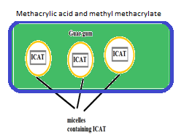  
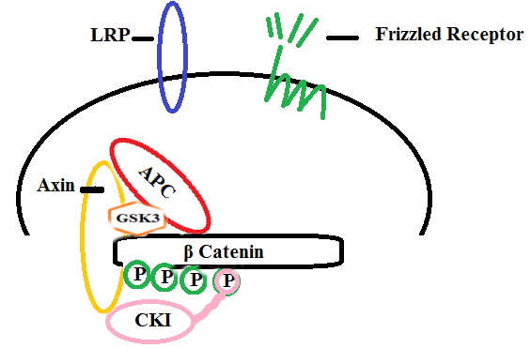  
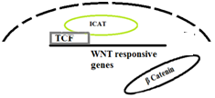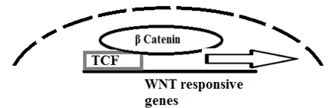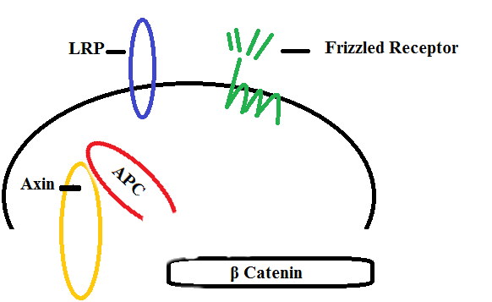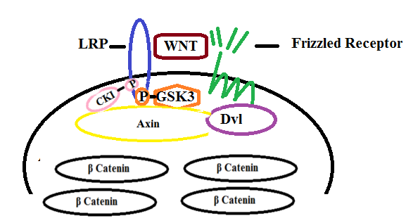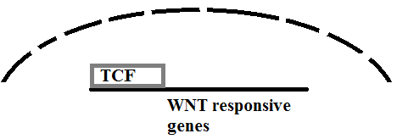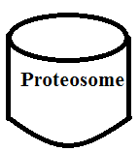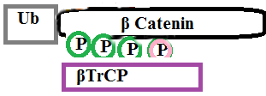  
  
  
  
  
  
  
  
  
  
  
  
  
  
  
  
  
  
  
  
  
***Conclusion***  
 FAP is a result of generally a nonsense or frameshift mutation on the fifth autosome's APC gene. Its main effect is colonic cancer. APC protein interacts with cell adhesion and tumor suppressing genes via the WNT pathway. When the APC protein is too short, these functions go awry and polyps begin to form. These polyps will manifest into tumors if left untreated.   
 Current treatments for FAP involve removing the colon followed by illeal pouch-anastomosis surgery or continent ileostomy so that the patient can continue disposing of bodily wastes in some manner. The surgery is followed by a COX inhibitor to prevent the reappearance of polyps in any remaining colonic tissue.   
 Experimental drugs in trial mainly treat colonic cancer in general and not the mechanisms by which colonic cancer manifest as a result of FAP. ICAT is a protein that shows promise in preventing beta-catenin from bonding with TCF, when the APC protein fails to form a destruction complex with beta-catenin, but ends up localizing in both the cytoplasm and nucleus. Localizing in the cytoplasm will have unknown side effects.   
 The proposed therapy is a capsule made of methacrylic acid and methyl methacrylate filled with guar gum to return the effect of an inactive WNT pathway. Suspended in the guar gum are engineered micelles that are filled with ICAT proteins. The methacrylic acid and methyl methacrylate will likely break up at the start of the colon. Guar gum ensures a slow distribution only in the colon of the micelles suspended in it. The micelles are engineered to be taken in by endocytosis, then localize at the nucleus by generating an NLS. Once the micelle detects the pH change in the nucleus, it will release ICAT proteins. The ICAT proteins will bind to TCF receptors so that beta-catenin cannot, basically inhibiting TCF. This returns the effect of an inactive WNT pathway.

Here are some of the abbreviations used:  
FAP - Familial adenomatous polyposis  
WNT stands for wingless integrated pathway. The pathway involves regulation of gene expression. When off, the related genes are not expressed.  
LRP - Low density lipoprotein receptor-related protein  
APC - Adenomatous polyposis coli  
GSK3 - Glycogen synthase kinase-3  
CKI - Cyclin-Dependent kinase inhibitor  
P - Phosphate group  
Ub - Ubiquitin  
βTrCP - beta-transducin repeat protein  
TCF - Transcription cofactor family.   
Dvl - a family of cytoplasmic phosphoproteins called disheveled.   
ICAT- an 81 amino acid protein that stands for (inhibitor of β-catenin and Tcf)

Micelle breaks up in nucleus due to pH change in nucleus. Releases ICAT. ICAT will inhibit TCF related genes from transcribing by blocking the beta-catenin bonding site.

Micelle generates a NLS to get into nucleus

Cells intake engineered micelles by endocytosis.

Guar gum breaks up in the colon

Methacrylic acid and methyl methacrylate breaks up near the colon.

The proposed cure is to have a capsule made of methacrylic acid and methyl methacrylate that breaks up somewhere at the end of the small intestine or the start of the colon. The capsule contains guar gum, which can only be broken down by bacteria in the colon. The guar gum contains micelles engineered to have cells intake it by endocytosis, then brought to the nucleus where it generates a nuclear localization signal. The micelles enters the nucleus where it breaks up due to pH differences and releases a protein called ICAT. ICAT will inhibit the transcription of TCF-related genes (aka WNT responsive genes). This restores the effect of the WNT pathway being off.

β-Catenin moves to the nucleus to bind with TCF, which begins transcribing genes.

The APC protein becomes too short to form the destruction complex when the WNT pathway is off, do beta catenin bonds with TCF and WNT genes are transcribed.

FAP is caused by nonsense or frame shift mutations on chromosome 5, and it affects epithelial tissue.

Normal WNT Pathway  
When On

Familial Adenomatous Polyposis

β-Catenin is targeted for destruction by a proteosome and TCF is never activated.

Normal WNT Pathway  
When Off  
Solid curved lines are cellular membrane. Dotted curved lines are nuclear membranes.

Bibliography

1. "Familial Adenomatous Polyposis." *Cancer.Net*. Ed. Cancer.Net Editorial Board. American Society of Clinical Oncology, 25 June 2012. Web. 13 Mar. 2016. <http://www.cancer.net/cancer-types/familial-adenomatous-polyposis>.

2. Faux, M. C., J. L. Ross, C. Meeker, T. Johns, H. Ji, R. J. Simpson, M. J. Layton, and A. W. Burgess. "Restoration of Full-length Adenomatous Polyposis Coli (APC) Protein in a Colon Cancer Cell Line Enhances Cell Adhesion." *National Center for Biotechnology Information*. U.S. National Library of Medicine, 26 Jan. 2004. Web. 20 Mar. 2016.

3. MacDonald, Bryan T., Keiko Tamai, and Xi He. "Wnt/β-Catenin Signaling: Components, Mechanisms, and Diseases." *Developmental Cell*. CellPress, 21 July 2009. Web. 20 Mar. 2016. <http://www.cell.com/action/showImagesData?pii=S1534-5807%2809%2900257- 3>.

4. Faux, M. C., J. L. Ross, C. Meeker, T. Johns, H. Ji, R. J. Simpson, M. J. Layton, and A. W. Burgess. "Restoration of Full-length Adenomatous Polyposis Coli (APC) Protein in a Colon Cancer Cell Line Enhances Cell Adhesion." *National Center for Biotechnology Information*. U.S. National Library of Medicine, 26 Jan. 2004. Web. 20 Mar. 2016. <http://www.ncbi.nlm.nih.gov/pubmed/14679305>.

5. Nisset, J. E., A. R. Redfield, F. Jin, K. A. Knudsen, K. R. Jonhson, and M. J. Wheelock. "Characterization of the Interactions of Alpha-catenin with Alpha-actinin and Beta- catenin/plakoglobin." *National Center for Biotechnology Information*. U.S. National Library of Medicine, 1997. Web. 20 Mar. 2016. <http://www.ncbi.nlm.nih.gov/pubmed/9152027>.

6. Barth, Angela I.M., Hector Y. Caro-Gonzalez, and W. James Nelson. "Role of Adenomatous Polyposis Coli (APC) and Microtubules in Directional Cell Migration and Neuronal Polarization." *National Center for Biotechnology Information*. U.S. National Library of Medicine, 1 June 2009. Web. 20 Mar. 2016. <http://www.ncbi.nlm.nih.gov/pmc/articles/PMC2673958/>.

7. Wehbi, Mohammad. "Familial Adenomatous Polyposis Treatment & Management." *Familial Adenomatous Polyposis Treatment & Management: Medical Care, Surgical Care, Consultations*. Medscape, 6 Mar. 2015. Web. 13 Mar. 2016. <http://emedicine.medscape.com/article/175377-treatment>.

8. Mayo Clinic Staff. "Familial Adenomatous Polyposis." *Treatment at Mayo Clinic*. Mayo Clinic, 20 Oct. 2015. Web. 13 Mar. 2016. <http://www.mayoclinic.org/diseases- cMonditions/familial-adenomatous-polyposis/care-at-mayo-clinic/treatment/con- 20035680>.

9. Khan, Michael. "Can We Safely Target the WNT Pathway?" *Nature Reviews*. Nature Reviews Drug Discovery, 1 July 2014. Web. 20 Mar. 2016. <http://www.nature.com/nrd/journal/v13/n7/full/nrd4233.html>.

10. "ICRT5, CRT Inhibitor (ab142141)." ICRT5. ABCAM, 17 Apr. 2013. Web. 20 Mar. 2016. <http://www.abcam.com/icrt5-crt-inhibitor-ab142141.html>.

11. "FAP Clinical Trial." Hereditary Colon Cancer Foundation. Hereditary Colon Cancer Foundation, 2016. Web. 20 Mar. 2016. <http://www.hcctakesguts.org/#!fap-clinical- trial/c1rcw>.  
12. Osby, Liv. "Young Mom Battling Colon Cancer Gets New Hope." The State. The Greenville News, 20 July 2015. Web. 15 May 2016. <http://www.thestate.com/living/health- fitness/article27968743.html>  
13. Parasanth, V. V., R. Jayaprakash, and Sam T. Matthew. "Colon Specific Drug Delivery Systems: A Review on Various Pharmaceutical Approaches." Colon Specific Drug Delivery Systems: A Review on Various Pharmaceutical Approaches (2012): 3. Journal of Applied Pharmaceutical Science. Journal of Applied Pharmaceutical Science, 16 Jan. 2012. Web. 15 May 2016. <http://www.japsonline.com/admin/php/uploads/363_pdf.pdf>.  
14. Rajpurohit, H., P. Sharma, S. Sharma, and A. Bhandari. "Polymers for Colon Targeted Drug Delivery." Indian Journal of Pharmaceutical Sciences. Medknow Publications, Nov.-Dec. 2010. Web. 03 Apr. 2016. <http://www.ncbi.nlm.nih.gov/pmc/articles/PMC3178968/>.  
15. Schultz, Nora. "Nanocarriers Come Through." MIT Technology Review. MIT Technology Review, 06 Jan. 2011. Web. 15 May 2016. <https://www.technologyreview.com/s/422297/nanocarriers-come-through>.

16. Deepthi, A., S. Raju, A. Kalyani, M. Udaya Kiran, and A. Vanaja. "Targeted Drug Delivery to the Nucleus and Its Potential Role in Cancer Chemotherapy." Targeted Drug Delivery to the Nucleus and Its Potential Role in Cancer Chemotherapy 5 (2013): n. pag. Journal of Pharmaceutical Sciences and Research. Journal of Pharmaceutical Sciences and Research, 2013. Web. 15 May 2016. <http://jpsr.pharmainfo.in/Documents/Volumes/vol5issue02/jpsr05021305.pdf>.  
17.Gottardi, CJ, and BM Gumbiner. "Role for ICAT in Beta-catenin-dependent Nuclear Signaling and Cadherin Functions." National Center for Biotechnology Information. U.S. National Library of Medicine, Apr. 2004. Web. 15 May 2016. <http://www.ncbi.nlm.nih.gov/pubmed/14613891>.

Closing Declaration: At the close of this assignment, I can attest to having done it by my own hand. If I received help from peers or from tutors in doing it, this was purely to understand the material, and I did not knowingly transfer the information from or to other sources (my peers or otherwise) in the process of doing this work

Student Signature: ________________________ Date:_________